**DDCO Mini Project**

**Project Title: Design & implement 8–bit prefix–adder.**

**Section : H**

**Name : Sushma G Herakal**

**SRN : PES1UG19CS528**

**Circuit Diagram:**

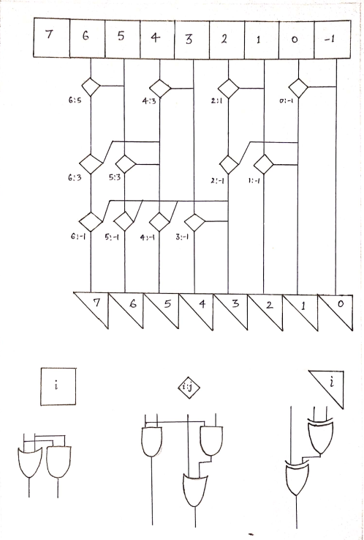

**Algorithm (if any):**

Parallel prefix adders

The PPA is like a Carry Look Ahead Adder. The production of the carriers the prefix adders can be designed in many different ways based on the different requirements. We use tree structure form to increase the speed of arithmetic operation. Parallel prefix adders are faster adders and these are faster adders and used for high performance arithmetic structures in industries. The parallel prefix addition is done in 3 steps.

1. Pre-processing stage

In this stage we compute, the generate and propagate signals are used to generate carry input of each adder. A and B are inputs.

Pi = Ai +Bi

Gi = Ai **.**Bi

2. Carry generation network

In this stage we compute carries corresponding to each bit. Execution is done in parallel form.After the computation of carries in parallel they are divided into smaller pieces. carry operator contain two AND gates, one OR gate. It uses propagate and generate as intermediate signals.

P(i:k) = P(i:j) **.**P(j-1:k)

G(i:k) = G(i:j) (G (j-1:k)**.**P(i:j))

3. Post processing stage

This is the final stage to compute the summation of input bits.

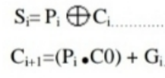

**Implementation (Code):**

module pg(input ai, bi, output pi, gi);

and2 and_0(ai, bi, gi);

or2 or_0(ai, bi, pi);

endmodule

module pg_grouped(input pi_k, gi_k, pk_j, gk_j, output pi_j, gi_j);

wire temp;

and2 and_0(pi_k, pk_j, pi_j);

and2 and_1(pi_k, gk_j, temp);

or2 or_1(gi_k, temp, gi_j);

endmodule

module sum(input gi_blk, ai, bi, output sum_i);

wire temp;

xor2 xor_0(ai, bi, temp);

xor2 xor_1(gi_blk, temp, sum_i);

endmodule

module carry(input p_block, g_block, cin, output cout);

wire temp;

and2 and_0(p_block, cin, temp);

or2 or_0(g_block, temp, cout);

endmodule

//8-bit Prefix Adder

module prefixAdder(input [7:0]ai, bi, output [7:0]sum);

//p_minus1 and g_minus1 are = 0 for the first prefix adder block

assign p_minus1 = 0;

assign g_minus1 = 0;

wire [7:0]pi, gi;

wire p0_minus1, p2_1, p4_3, p6_5, p1_minus1, p2_minus1, p5_3, p6_3, p3_minus1, p4_minus1, p5_minus1, p6_minus1, p7_minus1;

wire g0_minus1, g2_1, g4_3, g6_5, g1_minus1, g2_minus1, g5_3, g6_3, g3_minus1, g4_minus1, g5_minus1, g6_minus1, g7_minus1;

/*

assign p_minus1=1'b0;

assign g_minus1=1'b0; // pi and gi for -1th column is 0

*/

//Generation of pi, gi

pg p0g0(ai[0], bi[0], pi[0], gi[0]);

pg p1g1(ai[1], bi[1], pi[1], gi[1]);

pg p2g2(ai[2], bi[2], pi[2], gi[2]);

pg p3g3(ai[3], bi[3], pi[3], gi[3]);

pg p4g4(ai[4], bi[4], pi[4], gi[4]);

pg p5g5(ai[5], bi[5], pi[5], gi[5]);

pg p6g6(ai[6], bi[6], pi[6], gi[6]);

pg p7g7(ai[7], bi[7], pi[7], gi[7]);

//Generation of gi:-1 for all i

//Level 1

pg_grouped pg0_minus1(pi[0], gi[0], p_minus1, g_minus1, p0_minus1, g0_minus1);

pg_grouped pg2_1(pi[2], gi[2], pi[1], gi[1], p2_1, g2_1);

pg_grouped pg4_3(pi[4], gi[4], pi[3], gi[3] ,p4_3, g4_3);

pg_grouped pg6_5(pi[6], gi[6], pi[5], gi[5] ,p6_5, g6_5);

//Level 2

pg_grouped pg1_minus1(pi[1], gi[1], p0_minus1, g0_minus1, p1_minus1, g1_minus1);

pg_grouped pg2_minus1(p2_1, g2_1, p0_minus1, g0_minus1, p2_minus1, g2_minus1);

pg_grouped pg5_3(pi[5], gi[5], p4_3, g4_3, p5_3,g5_3);

pg_grouped pg6_3(p6_5, g6_5, p4_3, g4_3, p6_3,g6_3);

//Level 3

pg_grouped pg3_minus1(pi[3], gi[3], p2_minus1, g2_minus1,p3_minus1,g3_minus1);

pg_grouped pg4_minus1(p4_3, g4_3, p2_minus1, g2_minus1,p4_minus1,g4_minus1);

pg_grouped pg5_minus1(p5_3,g5_3, p2_minus1, g2_minus1,p5_minus1,g5_minus1);

pg_grouped pg6_minus1(p6_3,g6_3, p2_minus1, g2_minus1,p6_minus1,g6_minus1);

//Level 4

pg_grouped pg7_minus1(pi[7], gi[7], p6_minus1, g6_minus1,p7_minus1,g7_minus1);

sum s0(g_minus1, ai[0], bi[0], sum[0]);

sum s1(g0_minus1, ai[1], bi[1], sum[1]);

sum s2(g1_minus1, ai[2], bi[2], sum[2]);

sum s3(g2_minus1, ai[3], bi[3], sum[3]);

sum s4(g3_minus1, ai[4], bi[4], sum[4]);

sum s5(g4_minus1, ai[5], bi[5], sum[5]);

sum s6(g5_minus1, ai[6], bi[6], sum[6]);

sum s7(g6_minus1, ai[7], bi[7], sum[7]);

//assign cout=g7_minus1 + p7_minus1*g_minus1;

carry c_0(p7_minus1, g7_minus1, g_minus1, cout);

endmodule

**Output:**

